# Lambda, Map and Filter

Lambda examples-

Sum = lambda x,y = x+y #returns by default

Print(Sum(3,4)) # output = 7

Q = lambda a, b, c = x+y+ z**3

Print(Q(1,1,2)) # output = 10

Def fun(x):

Find = lambda x: x**4

Return(find(x))

Print(fun(2)) # output 16

Map examples-

Numbers = [10,20,30,40,50,60]

Result = map(lambda x: x*x, numbers)

Print(list(result))

Fruits = [‘apple’,’banana’,’pomogranate’,’orange’,’kiwi’]

Upperfr = map(lambda a: a.upper(), fruits)

Print(list(upperfr))

Resultfr = map(lambda a: a.capitalize(), fruits)

Print(list(Resultfr))

Def addfive(n):

Return n +5

Data = (1,2,3,4,5)

Results = map(addfive, Data)

Print(list(Results))

Import math

Nums = [2,3,4,6]

Print(list(map(math.factorial, nums)))

Def cube(x): return x*x*x

Map(cube, range(1,11))

Items = [1,2,3,4,5]

Sq = list(map(lambda x: x**2, items))

Print(sq)

Map_iterator = map(lambda c: c.upper(), fruits)

Print(list(map_iterator))

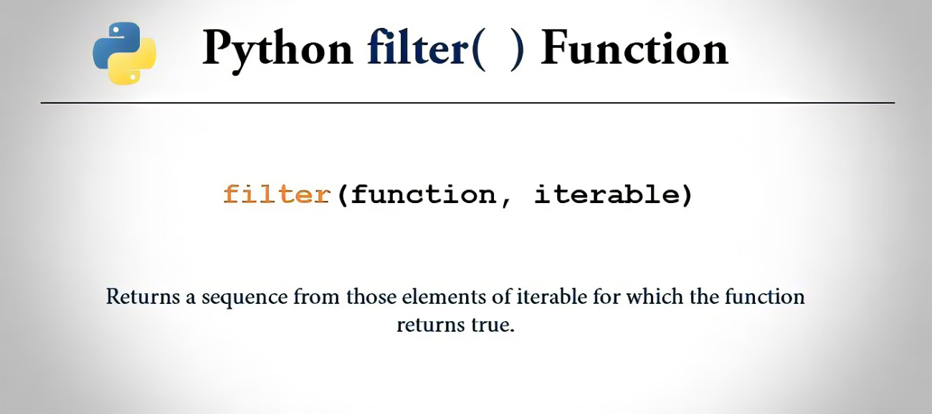

Filter examples-